PROTECTION FROM SEXUAL EXPLOITATION AND ABUSE (PSEA)

ACHIEVEMENT REPORT; *DECEMBER 2024 – JANUARY 2025*

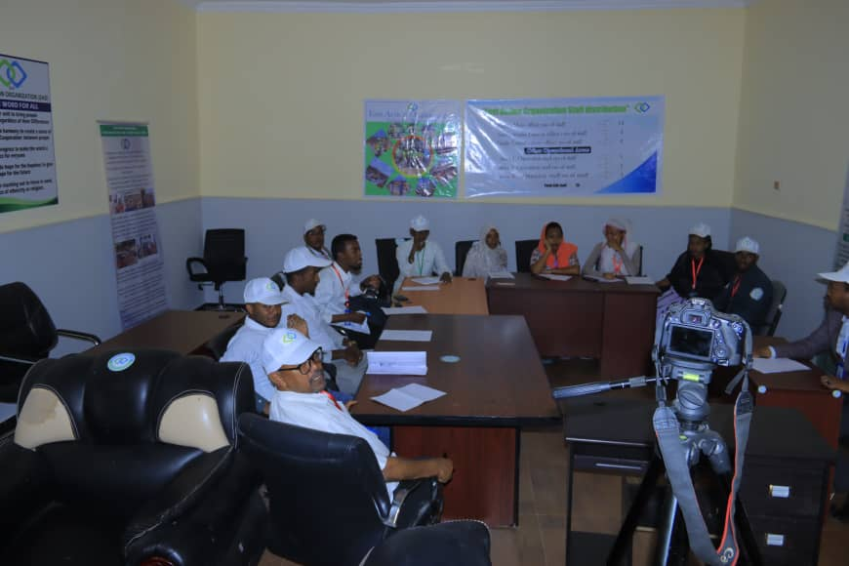

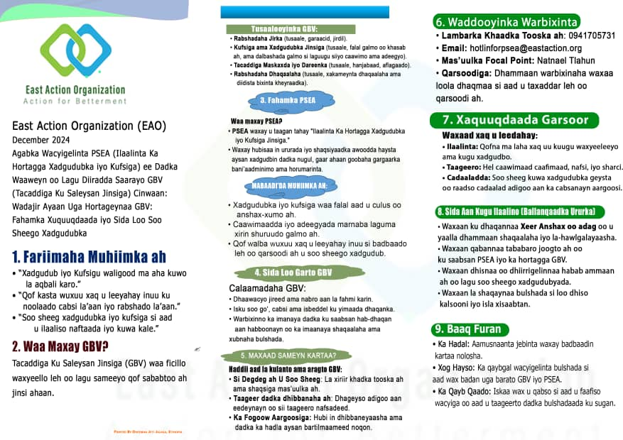

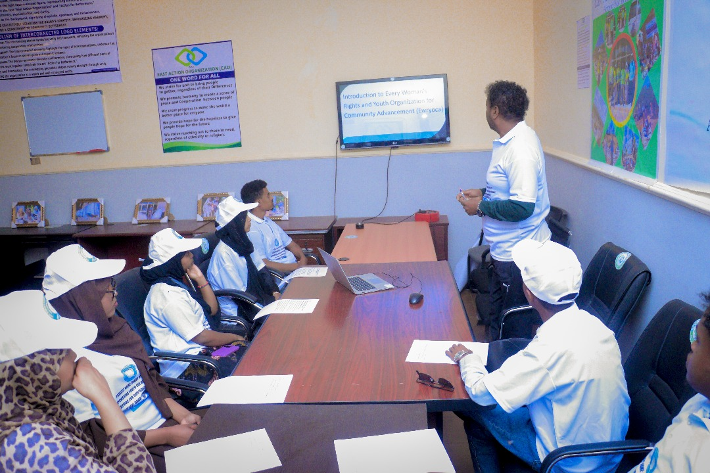

Protection from Sexual Exploitation and Abuse (PSEA) Achievement Report  
December 2024 - January 2025

Introduction  
East Action Organization (EAO) is a women-led, non-governmental organization dedicated to providing humanitarian support and services to vulnerable communities in Ethiopia. With a focus on addressing critical issues such as emergency response, health, gender-based violence (GBV), and sustainable livelihoods, EAO has been at the forefront of promoting the safety, dignity, and well-being of its beneficiaries. In line with its mission, East Action has implemented several initiatives in the area of Protection from Sexual Exploitation and Abuse (PSEA). PSEA refers to the prevention of any form of sexual exploitation or abuse in humanitarian interventions, ensuring that aid and services are provided in a safe and respectful manner.

UNHCR plays a critical role in supporting organizations like EAO in the prevention and response to sexual exploitation and abuse, providing guidelines, resources, and collaborative opportunities to strengthen PSEA efforts on the ground. The following report highlights key PSEA-related activities and achievements from December 2024 to January 2025.

1. PSEA Staff Training

Training for 25 Staff Members:  
A comprehensive PSEA training was conducted for 25 staff members to enhance their awareness and capacity regarding the prevention of sexual exploitation and abuse. This session provided key knowledge and skills to handle safeguarding matters effectively in humanitarian work.

Training for 5 New Recruits:  
Five new recruits received specialized PSEA staff training to ensure they are fully equipped to understand and manage safeguarding protocols within their roles.

PSEA Orientation for Ewryoca Staff (13 members):  
An awareness and orientation session was delivered to 13 staff members of Every Woman’s Rights and Youth Organization for Community Advancement (Ewryoca), strengthening their knowledge and capacity to prevent and address sexual exploitation and abuse.

2. Advocacy and Awareness Sessions

Youth Engagement on PSEA:  
A dedicated PSEA advocacy session was conducted for 15 youth leaders from Ewryoca Youth Organization. The session aimed to increase youth engagement, fostering a sense of responsibility and ownership regarding the protection of individuals from sexual exploitation and abuse.

Awareness Sessions Reached 423 Individuals:  
A total of 423 individuals (185 females, 238 males) were reached across the Fafan, Jarar Zone, and Shabele Zone areas through PSEA and safeguarding orientation sessions. These efforts significantly raised awareness in key communities, educating people on how to recognize, report, and prevent sexual exploitation and abuse.

3. Materials and Reporting Mechanisms

Translation and Distribution of PSEA Materials:  
In response to the needs of Somali-speaking communities, PSEA materials were translated into Somali and distributed to increase awareness and accessibility of information related to safeguarding and PSEA.

Community-Based Reporting Mechanisms:  
To improve accountability, PSEA complaint and suggestion boxes were established at key project locations. These reporting mechanisms empower community members to confidentially report concerns or allegations of sexual exploitation and abuse, strengthening the overall safeguarding efforts.

4. Distribution of Dignity Kits

Support for Displaced Girls:  
Dignity kits were distributed to 75 girls in the Qoloji IDP camp. These kits provide essential health, hygiene, and dignity items for girls, ensuring they have the resources they need during displacement and promoting their well-being in challenging circumstances.

5. Protection Mechanisms for Vulnerable Individuals

Safeguarding Vulnerable Community Members:  
Protection measures were implemented to ensure the safety and support of vulnerable individuals, particularly women and children, during emergencies. These measures created safe spaces and provided much-needed protection to those at risk of exploitation and abuse.

6. Referral Pathways for Survivors of GBV

Strengthening Referral Pathways:  
East Action strengthened the referral pathways for survivors of gender-based violence (GBV) in the project areas. This included connecting survivors to critical services such as medical, psychological, and legal support, ensuring that they receive the necessary care and attention in a timely manner.

7. Community-Based Protection Networks

Establishment of Local Protection Networks:  
Community-based protection networks were set up in vulnerable areas, engaging local leaders and stakeholders in the prevention and response to sexual exploitation and abuse. These networks ensure that community members play an active role in safeguarding efforts and provide a strong support system for those in need.

8. Engagement with the Ethiopia PSEA Network Membership

Ethiopia PSEA Network Participation:  
East Action joined the Ethiopia PSEA Network, appointed a dedicated focal person for PSEA-related matters, and attended the PSEA Network meeting on February 3, 2025. This meeting, held at the IOM Africa Conference Room, provided a valuable platform for exchanging knowledge and updates on PSEA initiatives and fostering collaboration across organizations.

PSEA Indicator Mapping & Action Plan Sign-Off:  
East Action participated in the PSEA indicator mapping exercise, aimed at strengthening monitoring mechanisms. The final reminder to complete the mapping by January 31 was issued.

Safer Recruitment Efforts:  
Efforts were made to enhance safer recruitment practices within East Action, ensuring that all staff and volunteers involved in humanitarian work adhere to PSEA standards.

Participation in CHS Alliance Webinar:  
East Action also participated in the CHS Alliance webinar, which focused on safeguarding practices and standards in humanitarian settings.

Job Vacancy Announcement:  
A safeguarding position was announced within the organization, in collaboration with SNV Ethiopia, to further strengthen PSEA efforts.

Conclusion

East Action Organization, in partnership with stakeholders and UNHCR, continues to prioritize the safety and dignity of all individuals within the communities it serves. Through comprehensive training, advocacy, awareness, and strengthened community-based mechanisms, significant progress has been made in preventing and responding to sexual exploitation and abuse. As the organization moves forward, further efforts will be made to enhance PSEA capacity and ensure a secure environment for all beneficiaries.

This report will be submitted to UNHCR Protection for review and continued collaboration in the field of PSEA.

9. Annexed .photo and Sample of Translation and Distribution of PSEA Materials

